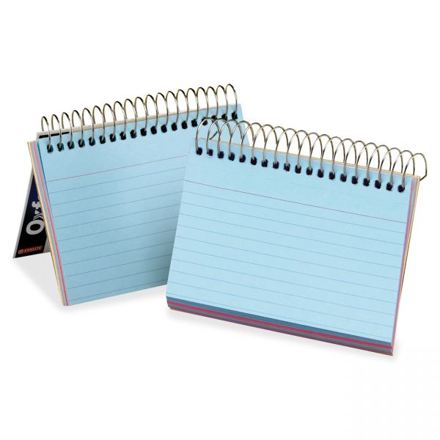
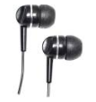
Materials Needed for Geometry
Earbuds (for in-class use of provided computers)
2 inch binder with dividers
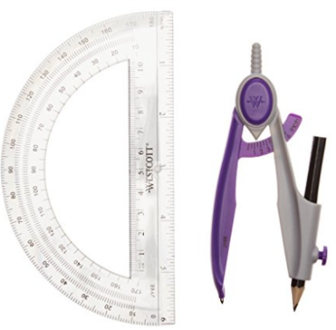
2 Spiral-bounded index cards (one for your summer assignment & one for the school year)
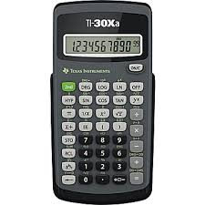
2 packs of graph paper
Lined paper
Pencils
Erasers
Protractor & Compass
Calculator TI-30Xa

